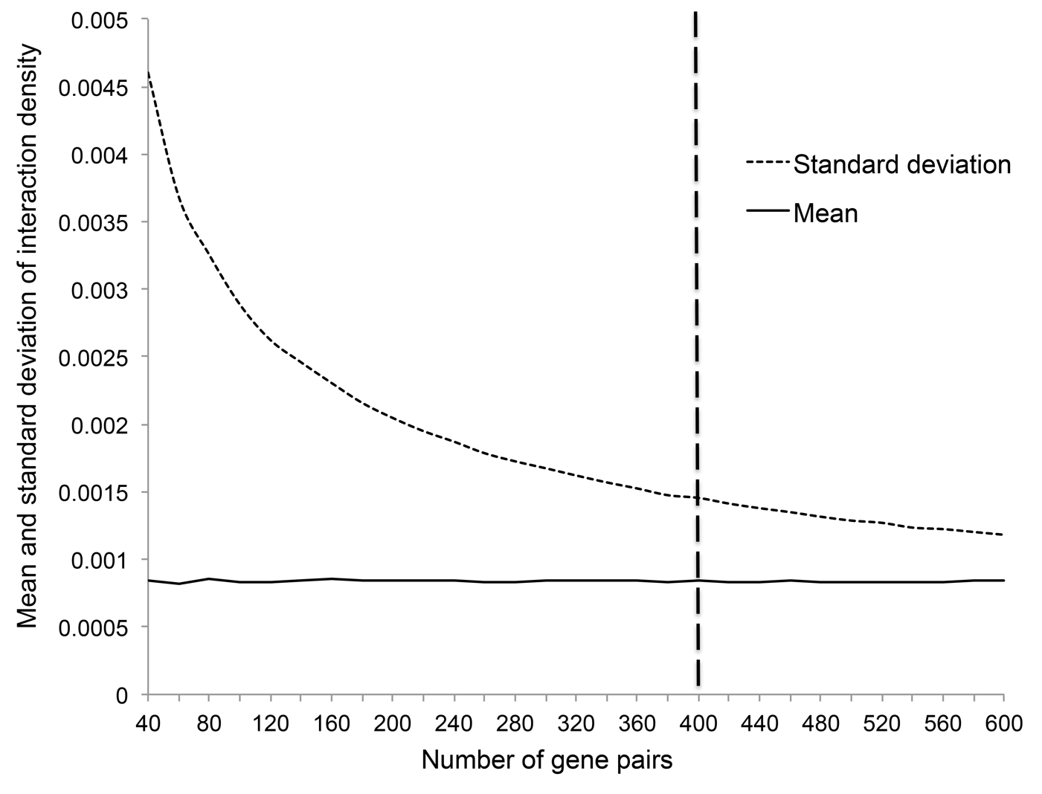
Mean and standard deviation of the expected interaction density between random genes.

